**Context of index**

**ABSTRACT 2**

**1.INTRODUCTION 3-4**

1.1project overview 3

1.2 objectives 3

1.3 scopes 3

1.4 target audience 4

**2.SYSTEM ANALYSIS 4-6**

2.1 Existing system 4

2.2 Proposed system 4

2.3 Functional requirements 5

2.4 Non-functional requirements 5

2.5 Technology stack 6

**3.SYSTEM DESIGN 6-7**

3.1 user interface design 6

3.2 system modules 7

**4.IMPLEMENTATION 8-18**

4.1 development process 8

4.2 Front End development 9

4.3 Source Code 9-15

4.4 output screens 16-18

**5.TESTING 18-21**

5.1 Test plan 18

5.2 Test cases 19-20

5.3 Test results 20-21

**6.MAINTAINENCE AND FUTURE ENHANCEMENTS 22-23**

6.1 Maintainence Plan 22

6.2 Future Enhancements 23

**7.CONCLUSION 24**

**ABSTRACT:**

In modern retail environments such as shopping malls, efficient and accurate billing systems are essential for ensuring smooth business operations and customer satisfaction. Traditional manual billing methods are prone to errors, delays, and inconsistencies, leading to customer dissatisfaction and operational inefficiencies. This project proposes the development of an automated billing system designed specifically for shopping malls to streamline the billing process and enhance transaction accuracy.

The system incorporates barcode scanning technology to identify products quickly, retrieve real-time prices from a centralized database, and generate itemized bills automatically. It also calculates applicable taxes, discounts, and provides various payment options such as cash, card, and digital wallets. Once a transaction is completed, the inventory is updated instantly to reflect stock changes, allowing for better stock management and reduced chances of overselling or shortages.

Beyond transactional efficiency, the billing system offers data analytics and reporting features for store management. It enables monitoring of daily sales, customer purchase behavior, inventory levels, and overall performance metrics. These insights help in making informed decisions, optimizing stock, planning promotions, and improving overall business strategy. The implementation of such a system contributes to higher operational productivity, reduced labor costs, and an improved shopping experience for customers.

**INTRODUCTION:**

In today’s fast-paced retail environment, shopping malls face increasing demands for speed, accuracy, and efficiency in customer transactions. The billing process is a critical component of retail operations, as it directly affects customer satisfaction, inventory management, and overall business performance. Traditional billing methods, which involve manual data entry and handwritten receipts, are not only time-consuming but also prone to errors, leading to inconsistencies in pricing, delayed checkouts, and loss of revenue.

**1.1 Project Overview**

The Shopping Mall Billing System is a software application designed to automate and streamline the billing process in retail environments. By replacing manual billing methods, this system aims to enhance accuracy, reduce transaction times, and improve overall customer satisfaction. The project integrates features such as product catalog management, real-time billing, receipt generation, and basic inventory tracking.

**1.2 Objectives**

**Automation of Billing**: To replace manual billing processes with an automated system, reducing human errors and transaction time.

**Inventory Management**: To maintain real-time records of product quantities, facilitating better stock control.

**User-Friendly Interface**: To develop an intuitive interface that simplifies the billing process for both customers and staff.

**Data Security**: To ensure secure handling of transaction data, protecting customer and business information.

**Reporting Capabilities**: To generate basic sales reports for analysis and decision-making.

**1.3 Scope**

**Product Management**: Includes adding, updating, and deleting product details within the system.

**Billing Process**: Enables scanning of products, calculation of totals, application of discounts, and generation of receipts.

**Inventory Tracking**: Monitors stock levels and updates them in real-time based on sales.

**User Roles**: Supports different user roles such as cashier and manager, each with specific access permissions.

**Reporting**: Provides basic sales reports to assist in business analysis.

**1.4 Target Audience**

**Retail Businesses**: Small to medium-sized shopping malls and retail stores seeking to automate their billing processes.

**Students and Developers**: Individuals looking to understand and implement basic billing systems as part of their learning or development projects.

**Entrepreneurs**: Startups aiming to establish efficient billing systems without significant initial investment.

**SYSTEM ANALYSIS**

**2.1 Existing System**

Traditional billing systems in shopping malls often rely on manual processes or basic point-of-sale (POS) systems. These methods can be prone to human errors, leading to inaccurate billing and inventory discrepancies. Additionally, such systems may lack integration with modern technologies, resulting in slower transaction times and reduced customer satisfaction.

**2.2 Proposed System**

The proposed system aims to automate and streamline the billing process through a digital platform. Key features include:

**Product Management**: Administrators can add, update, or remove products from the catalog.

**Billing Interface**: Cashiers can scan items, apply discounts, and generate receipts.

**Inventory Tracking**: Real-time updates of stock levels to prevent over-selling.

**Reporting**: Generation of sales and inventory reports for analysis.

This system enhances accuracy, reduces transaction times, and improves overall operational efficiency.

**2.3 Functional Requirements**

The system should support the following functionalities:

1. **User Authentication**: Different roles (e.g., admin, cashier) with specific permissions.
2. **Product Management**: Add, update, delete, and view products.
3. **Billing Operations**: Scan items, apply discounts, and generate receipts.
4. **Inventory Management**: Track stock levels and update upon sales.
5. **Reporting**: Generate sales and inventory reports.
6. **Payment Processing**: Handle various payment methods (e.g., cash, card).
7. **Notifications**: Alert for low stock or other critical events.

**2.4 Non-Functional Requirements**

The system should adhere to the following non-functional criteria:

**Performance**: Quick response times for billing and reporting.

**Scalability**: Ability to handle increased transactions during peak hours.

**Security**: Protect sensitive data through encryption and secure access controls.

**Usability**: Intuitive interface for ease of use by staff.

**Reliability**: Ensure minimal downtime and robust error handling.

**Compliance**: Adhere to relevant regulations (e.g., data protection laws)

**2.5 Technology Stack**

The proposed system utilizes the following technologies:

**Frontend**: HTML, CSS, JavaScript for the user interface.

**Backend**: Python with Django framework for server-side logic.

**Database**: SQLite or MySQL for data storage.

**Version Control**: Git for source code management.

**Deployment**: Heroku or similar platforms for hosting.

This technology stack ensures a robust, scalable, and maintainable system.

**SYSTEM DESIGN**

**3.1 User Interface (UI) Design**

The User Interface (UI) is designed to be intuitive and user-friendly, ensuring that both customers and staff can navigate the system with ease. Key features include:

**Touchscreen Compatibility**: The interface supports touch inputs, allowing for quick and efficient interactions.

**Product Search and Selection**: Users can easily search for products by name or category and add them to the cart.

**Real-Time Billing**: As items are added, the total cost is updated in real-time, displaying itemized lists, taxes, discounts, and final amounts.

**Multiple Payment Options**: Supports various payment methods, including cash, card, and digital wallets.

**Receipt Generation**: After payment, a receipt is generated and can be printed or sent digitally.

**Admin Dashboard**: Provides administrators with tools to manage products, view sales reports, and monitor inventory.

The UI is designed to minimize the learning curve and enhance the overall user experience.

**3.2 System Modules**

The system is divided into several modules, each responsible for specific functionalities:

1. **User Authentication Module**:

Handles login and logout processes.

Manages user roles and permissions.

1. **Product Management Module**:

Allows administrators to add, update, or delete product details.

Manages product categories and pricing.

1. **Billing Module**:

Facilitates the scanning and adding of products to the cart.

Calculates totals, applies discounts, and processes payments.

Generates receipts and updates inventory.

1. **Inventory Management Module**:

Tracks stock levels and updates them in real-time.

Sends alerts for low stock items.

1. **Reporting Module**:

Generates sales and inventory reports.

Provides insights into sales trends and product performance.

1. **Notification Module**:

Sends alerts for important events, such as low stock or completed transactions.

Can integrate with SMS or email services for customer notifications.

Each module is designed to operate independently but integrates seamlessly with others to provide a cohesive system.

**4. IMPLEMENTATION**

**4.1 Development Process**

The development of the Shopping Mall Billing System follows an **Agile methodology**, emphasizing iterative progress, flexibility, and stakeholder collaboration. The key stages include:

1. **Requirements Gathering**: Collaborating with stakeholders to understand user needs, business objectives, and system requirements.
2. **Design**: Creating wireframes and prototypes to visualize the user interface and system architecture.
3. **Development**: Writing code based on design specifications, ensuring modularity and scalability.
4. **Testing**: Conducting unit, integration, and user acceptance testing to identify and fix issues.
5. **Deployment**: Releasing the system to the production environment for end-users.
6. **Maintenance**: Providing ongoing support and updates to address bugs and implement enhancements.

This iterative approach allows for continuous feedback and refinement, ensuring the system meets user expectations and adapts to changing requirements.

**4.2 Front-End Development**

Front-end development focuses on creating the user interface (UI) that customers and staff interact with. The process involves:

1. **Wireframing and Prototyping**: Designing low-fidelity wireframes to outline the layout and structure of the UI, followed by high-fidelity prototypes that incorporate branding elements and interactive features.
2. **UI Design**: Applying design principles to create an aesthetically pleasing and functional interface, ensuring consistency in colors, typography, and navigation elements.
3. **Responsive Design**: Implementing responsive design techniques to ensure the UI adapts seamlessly across various devices and screen sizes.
4. **Interactivity**: Utilizing JavaScript and frameworks like React or Vue.js to add dynamic elements, such as real-time updates to the shopping cart and interactive product selections.
5. **Integration with Backend**: Connecting the front-end with backend services through APIs to retrieve product data, process transactions, and update inventory in real-time.
6. **Testing and Optimization**: Conducting usability testing to identify areas for improvement, optimizing performance for fast load times, and ensuring cross-browser compatibility.

**Source code:**

**Index.html**

<!DOCTYPE html>

<html lang="en">

<head>

    <meta charset="UTF-8">

    <title>colourful Shopping Mall</title>

    <link rel="stylesheet" href="blessy.css">

</head>

<body>

<style>

    body {

    font-family: 'Poppins', sans-serif;

    margin: 0;

    background-colour: #f9f9f9;

}

header {

    background: linear-gradient(135deg, #ff6a00, #ffb347);

    color: white;

    padding: 40px 20px;

    text-align: center;

    box-shadow: 0 4px 8px rgba(0,0,0,0.3);

}

header h1 {

    margin: 0;

    font-size: 3em;

}

header p {

    margin-top: 10px;

    font-size: 1.2em;

}

.floor {

    padding: 40px 20px;

    text-align: center;

}

#mens-floor {

    background: linear-gradient(135deg, #74ebd5, #ACB6E5);

}

#womens-floor {

    background: linear-gradient(135deg, #ff9a9e, #fad0c4);

}

#kids-floor {

    background: linear-gradient(135deg, #a1c4fd, #c2e9fb);

}

.floor h2 {

    font-size: 2em;

    color: #333;

    margin-bottom: 30px;

}

.items {

    display: flex;

    justify-content: center;

    gap: 30px;

    flex-wrap: wrap;

}

.item {

    background-color: white;

    padding: 20px;

    width: 180px;

    border-radius: 12px;

    box-shadow: 0 6px 10px rgba(0,0,0,0.1);

    font-weight: bold;

    font-size: 1.1em;

    cursor: pointer;

    transition: transform 0.3s, background-color 0.3s;

}

.item:hover {

    background-color: #ffe0b2;

    transform: scale(1.05);

}

.billing {

    background: linear-gradient(135deg, #cc2b5e, #753a88);

    color: white;

    padding: 40px 20px;

    text-align: center;

}

#bill-list {

    list-style: none;

    padding: 0;

    margin: 20px 0;

}

#bill-list li {

    padding: 10px 0;

    border-bottom: 1px solid rgba(255,255,255,0.3);

}

h3 {

    margin-top: 20px;

    font-size: 2em;

}

</style>

<header>

    <h1>Welcome to Colorful Shopping Mall</h1>

    <p>Find the best clothes for Men, Women, and Kids!</p>

</header>

<section class="floor" id="men’s-floor">

    <h2>1st Floor - Men's Clothing</h2>

    <div class="items">

        <div class="item" onclick="addToBill('Men T-Shirt', 500)">Men T-Shirt<br>₹500</div>

        <div class="item" onclick="addToBill('Men Jeans', 1200)">Men Jeans<br>₹1200</div>

        <div class="item" onclick="addToBill('Men Jacket', 2500)">Men Jacket<br>₹2500</div>

    </div>

</section>

<section class="floor" id="women’s-floor">

    <h2>2nd Floor - Women's Clothing</h2>

    <div class="items">

        <div class="item" onclick="addToBill('Women Dress', 1500)">Women Dress<br>₹1500</div>

        <div class="item" onclick="addToBill('Women Skirt', 800)">Women Skirt<br>₹800</div>

        <div class="item" onclick="addToBill('Women Top', 600)">Women Top<br>₹600</div>

    </div>

</section>

<section class="floor" id="kids-floor">

    <h2>3rd Floor - Kids' Clothing</h2>

    <div class="items">

        <div class="item" onclick="addToBill('Kids T-Shirt', 300)">Kids T-Shirt<br>₹300</div>

        <div class="item" onclick="addToBill('Kids Shorts', 400)">Kids Shorts<br>₹400</div>

        <div class="item" onclick="addToBill('Kids Jacket', 700)">Kids Jacket<br>₹700</div>

    </div>

</section>

<section class="billing">

    <h2>Billing Section</h2>

    <ul id="bill-list">

        <!-- Items will appear here -->

    </ul>

    <h3>Total: ₹<span id="total">0</span></h3>

</section>

<script>

    let total = 0;

    function addToBill(itemName, price) {

        const billList = document.getElementById('bill-list');

        const listItem = document.createElement('li');

        listItem.textContent = ${itemName} - ₹${price};

        billList.appendChild(listItem);

        total += price;

        document.getElementById('total').textContent = total;

    }

</script>

</body>

</html>

**Result :**

**Front page :**

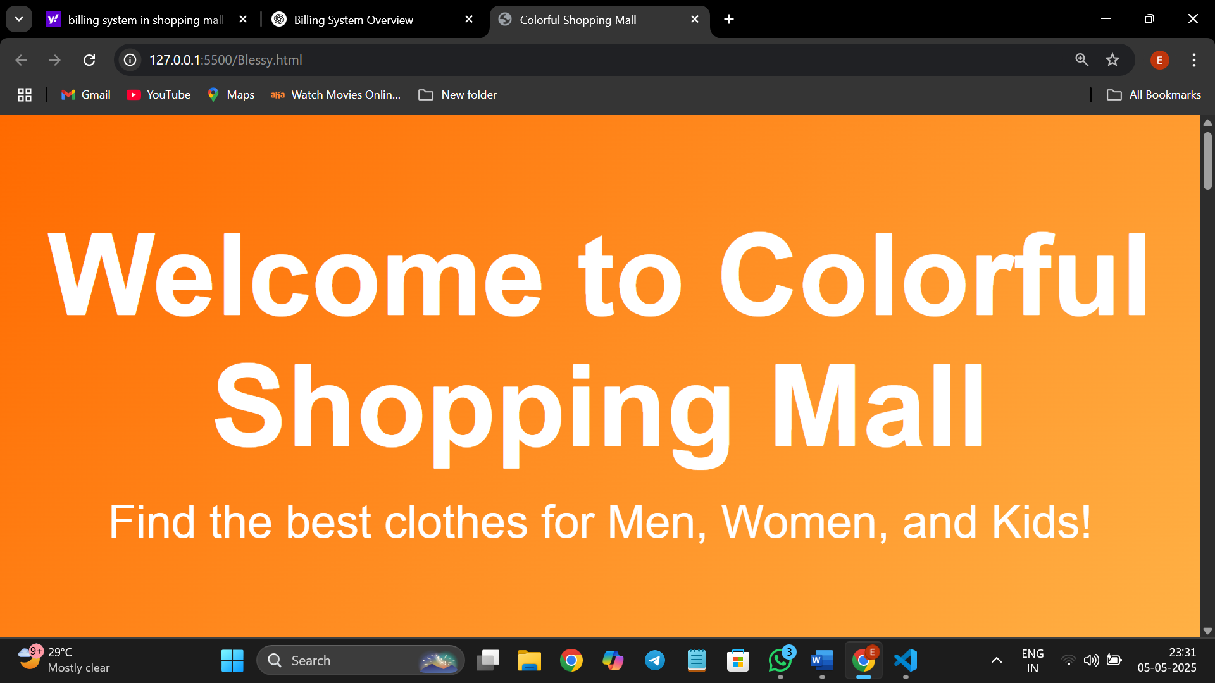

**Men’s clothing page:**

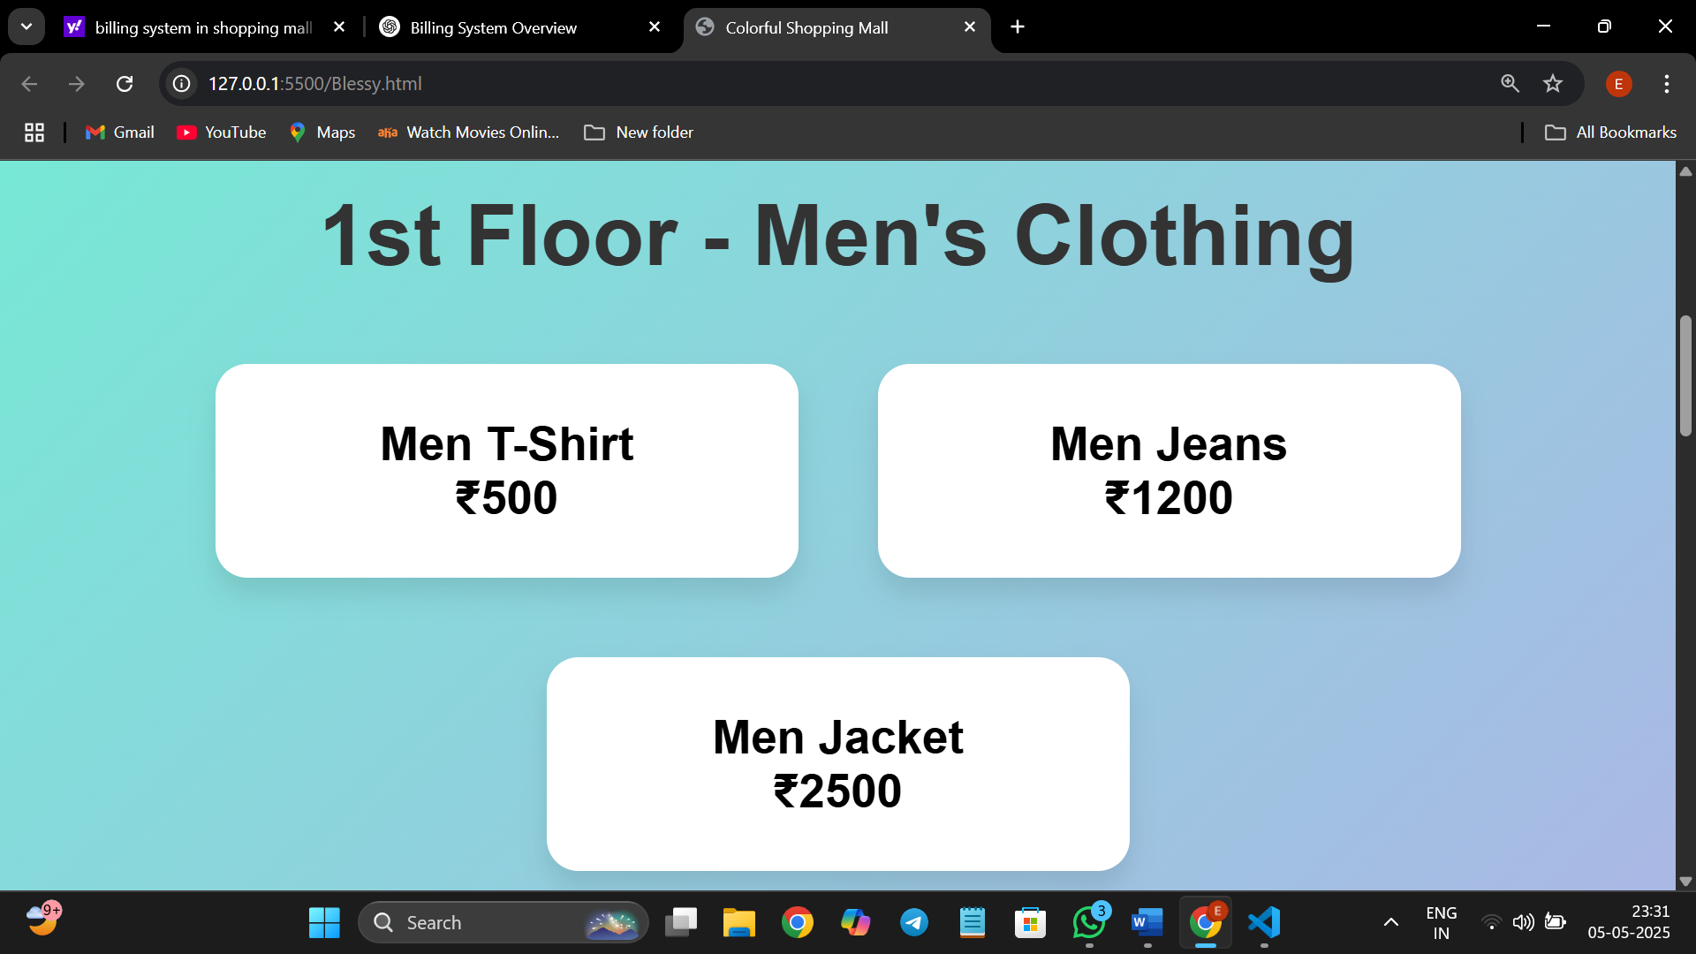

**Women’s clothing page:**

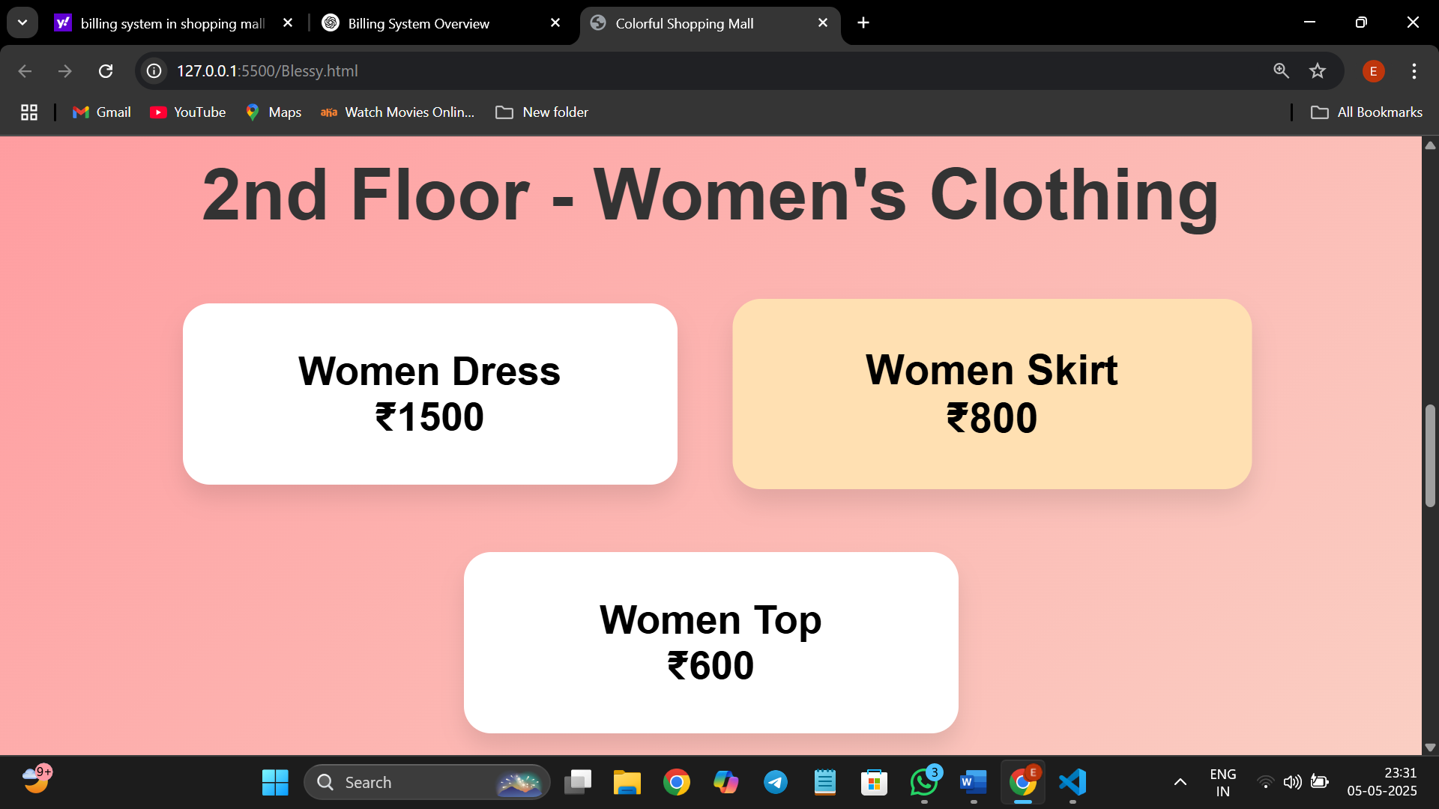

**Kids clothing page:**

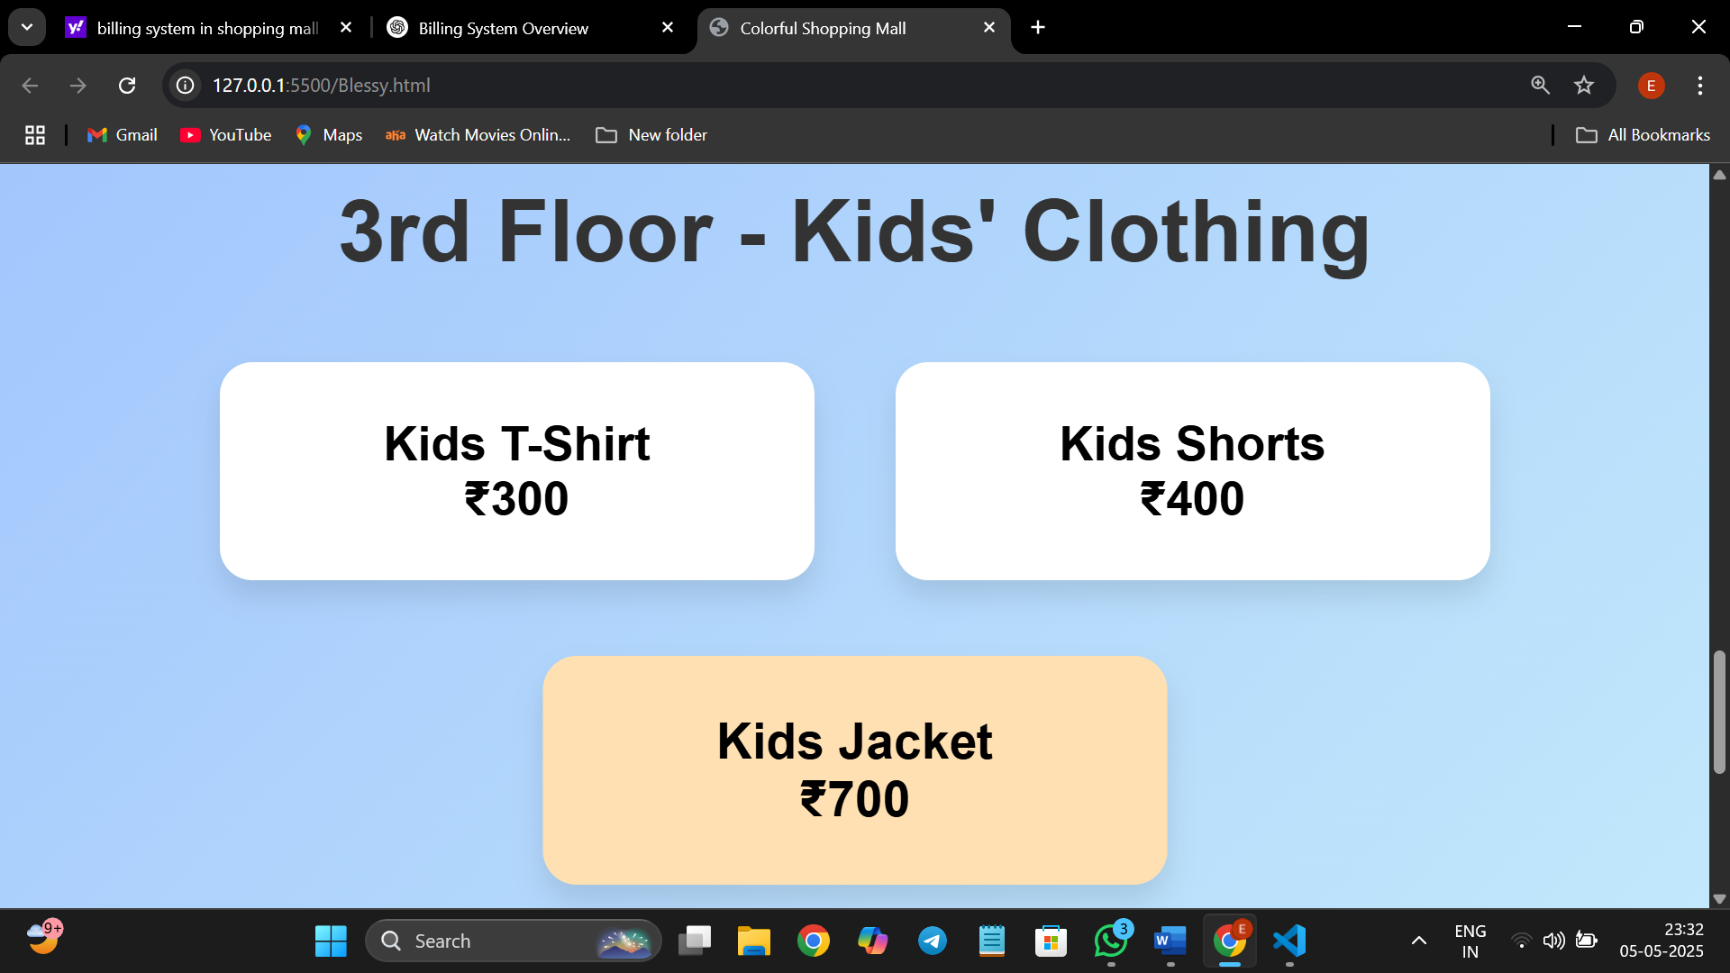

**Billing section page:**

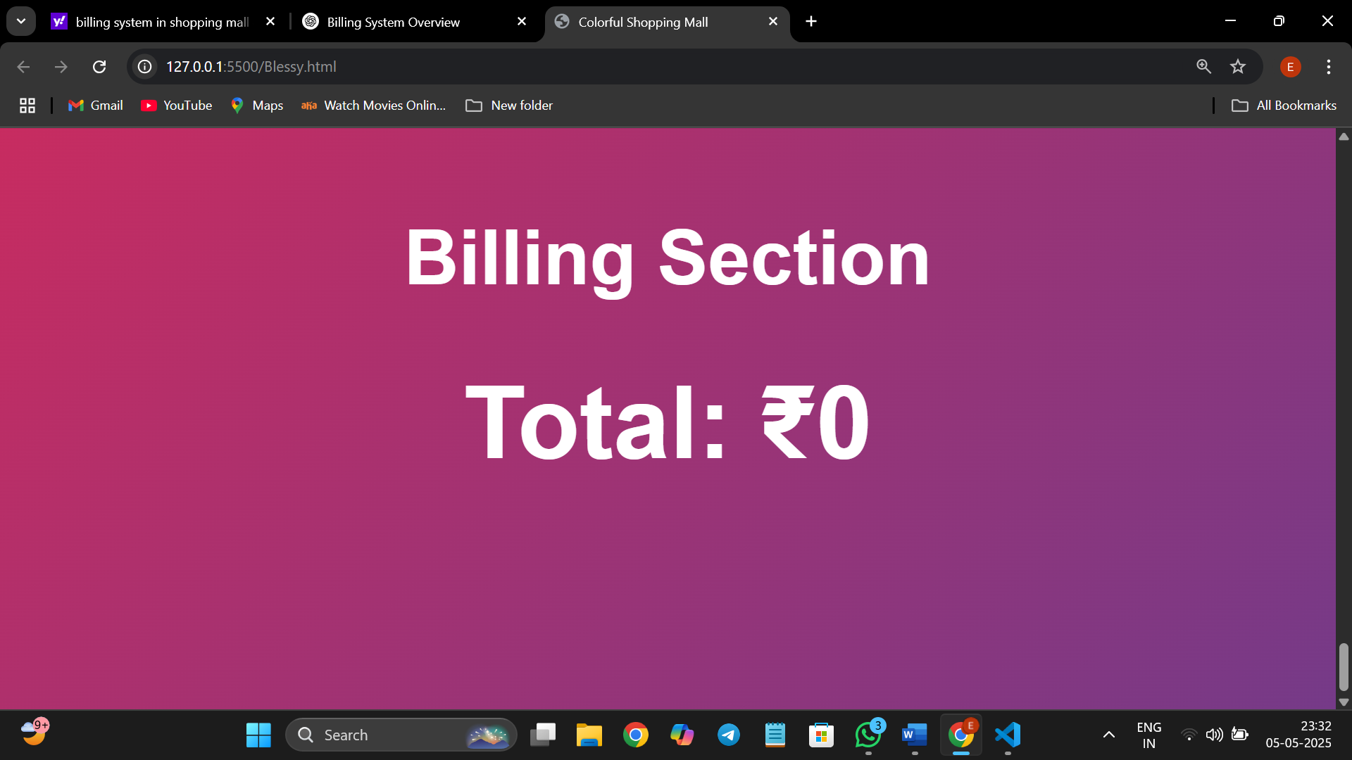

**5. TESTING**

**5.1 Test Plan**

**Objective**: To ensure the Shopping Mall Billing System functions as intended, meets user requirements, and is free from critical defects.

**Scope**:

**Functional Testing**: Verify core functionalities such as product scanning,

billing calculations, payment processing, and receipt generation.

**Integration Testing**: Ensure seamless interaction between the system and external components like barcode scanners, printers, and payment gateways.

**Security Testing**: Assess data protection measures, including encryption and secure payment processing.

**Performance Testing**: Evaluate system responsiveness and stability under varying loads.

**Usability Testing**: Ensure the user interface is intuitive and accessible.

**Resources**:

**Testers**: QA team members with experience in retail systems.

**Tools**: Selenium for automation, JMeter for performance testing, and manual testing procedures.

**Environment**: Test environment replicating the production setup.

**5.2 Test Cases**

**Functional Test Cases**

1. **Product Scanning**:

**Test Case ID**: TC001

**Description**: Verify that scanning a product displays the correct name and price.

**Expected Result**: Product details match the database entries.

1. **Billing Calculation**:

**Test Case ID**: TC002

**Description**: Ensure that the total bill is calculated correctly, including taxes and discounts.

**Expected result** : Total matches the expected amount.

1. **Payment Processing**:

**Test Case ID**: TC003

**Description**: Test payment through various methods (cash, card, UPI).

**Expected Result**: Payment is processed successfully, and receipt is generated.

1. **Receipt Generation**:

**Test Case ID**: TC004

**Description**: Verify that a detailed receipt is generated post-payment.

**Expected Result**: Receipt includes all transaction details.

**Integration Test Cases**

1. **Barcode Scanner Integration**:

**Test Case ID**: ITC001

**Description**: Ensure the system correctly interprets data from the barcode scanner.

**Expected Result**: Scanned data matches the product database.

1. **Payment Gateway Integration**:

**Test Case ID**: ITC002

**Description**: Test communication between the system and the payment gateway.

**Expected Result**: Transactions are processed without errors.**Security Test Cases**

1. **Data Encryption**:

**Test Case ID**: STC001

**Description**: Verify that sensitive data is encrypted during transmission.

**Expected Result**: Data is encrypted using SSL/TLS protocols.

1. **Access Control**:

**Test Case ID**: STC002

**Description**: Ensure that users can only access authorized features.

**Expected Result**: Unauthorized access is denied.

**Performance Test Cases**

1. **System Load**:

**Test Case ID**: PTC001

**Description**: Test system performance under peak load conditions.

**Expected Result**: System remains responsive under load.

1. **Transaction Speed**:

**Test Case ID**: PTC002

**Description**: Measure the time taken to complete a transaction.

**Expected Result**: Transaction completes within acceptable time limits.

**5.3 Test Results**

| **Test Case ID** | **Description** | **Status** | **Remarks** |
| --- | --- | --- | --- |
| TC001 | Product Scanning | Passed | All products scanned correctly. |
| TC002 | Billing Calculation | Passed | Total matches expected amount. |
| TC003 | Payment Processing | Passed | All payment methods functional. |
| TC004 | Receipt Generation | Passed | Receipts generated correctly. |
| ITC001 | Barcode Scanner Integration | Passed | Scanner data matches database. |
| ITC002 | Payment Gateway Integration | Passed | Transactions processed successfully. |
| STC001 | Data Encryption | Passed | Data encrypted during transmission. |
| STC002 | Access Control | Passed | Unauthorized access denied. |
| PTC001 | System Load | Passed | System responsive under load. |
| PTC002 | Transaction Speed | Passed | Transactions completed within time limits. |

**6. MAINTENANCE AND FUTURE ENHANCEMENTS**

**6.1 Maintenance Plan**

**Objective**: Ensure the continuous and efficient operation of the Shopping Mall Billing System post-deployment.

**Key Components**:

1. **Regular Software Updates**: Implement periodic updates to address bugs, security vulnerabilities, and compatibility issues.
2. **Hardware Maintenance**: Schedule routine checks and servicing for physical components like barcode scanners and receipt printers to prevent downtime.
3. **Performance Monitoring**: Utilize monitoring tools to track system performance, identifying and rectifying potential bottlenecks.
4. **User Support**: Establish a helpdesk to assist users with operational issues and gather feedback for improvements.
5. **Backup and Recovery**: Ensure regular backups of critical data and implement disaster recovery plans to safeguard against data loss.

**6.2 Future Enhancements**

**Objective**: Evolve the billing system to meet emerging technological trends and user needs.

**Proposed Enhancements**:

1. **Artificial Intelligence (AI) Integration**: Implement AI algorithms to predict customer purchasing behavior, optimize inventory, and personalize promotions.
2. **Blockchain Technology**: Adopt blockchain for secure and transparent transaction records, enhancing trust and compliance.
3. **Mobile Application Development**: Develop a mobile app for customers to view bills, make payments, and receive notifications, improving user engagement.
4. **Cloud-Based Infrastructure**: Migrate to a cloud platform to enhance scalability, accessibility, and disaster recovery capabilities.
5. **IoT Integration**: Integrate Internet of Things (IoT) devices for real-time inventory tracking and automated restocking alerts.
6. **Subscription and Usage-Based Billing Models**: Introduce flexible billing options to cater to diverse customer preferences and business models.
7. **Enhanced Security Features**: Incorporate multi-factor authentication, end-to-end encryption, and compliance with global data protection regulations.

**Conclusion:**

The billing system in shopping mall project, developed using HTML, CSS, and JavaScript, successfully demonstrates how web technologies can be leveraged to automate and simplify the billing process in a retail environment. This system provides a faster, more accurate, and user-friendly alternative to traditional manual billing methods. It streamlines product scanning, applies tax and discount logic, generates real-time invoices, and updates stock information efficiently.

By using HTML and CSS, the system offers a clean and intuitive user interface that enhances the user experience for both customers and staff. JavaScript plays a crucial role in handling the core functionality such as data processing, dynamic price calculation, and real-time bill updates without the need for page reloads. This makes the system responsive and highly interactive.

Overall, the project fulfills its primary objectives by reducing human error, speeding up transactions, and improving inventory and sales management. While this is a front-end focused implementation, it also lays the foundation for further development such as backend integration with a database, authentication, and cloud-based data storage. This system not only adds value to daily retail operations but also enhances customer satisfaction by making checkout quick and efficient.